DAP-PROVMEX PÁLAVSKÁ REGATTA 2010

ISAF World Sailing Ranking List Event: GR 3 – Laser S+R, Finn
Czech Sailing Cup for all classes.

7 - 9 May 2010, Nové Mlýny lake – Pavlov, Czech republic, YC Dyje Břeclav

SAILING INSTRUCTIONS

(Note: “Notice of race” will be posted on the Race committee notice board during the regatta)

1. RULES

1.1 The regatta will be governed by the rules as defined in the Racing Rules of Sailing 2010-2012 (RRS).
1.2 When there is any disagreement on the interpretation of the rules defined by pt.1.1 of these SI, then the English Edition shall prevail.
1.3 The 720º turn penalty (RRS, No. 44.1) shall be applied.
  - Judging on the water: The Appendix P (RRS) shall apply. An action or non-action of the protest committee (PC) according to this instruction shall not be a subject of an ask for redress. This changes the rule 62.1(a). The boat, which accepts the penalty, cannot be protested by another boat for violating this rule.

2. CLASSES

Regatta is organised for Finn, Laser Standard, Laser Radial and Europe classes. For all classes as regatta of the Czech cup. The regatta is included in ISAF World Sailing Ranking List for Laser Standard, Laser Radial and Finn classes.

3. ENTRIES

All participants have to register to the race in compliance with the Notice of race. (No.8)

4 NOTICES, CHANGES AND AMENDMENTS

4.1 Race committee (RC) notice board and Protest committee notice board will be placed near the Race Committee office.
4.2 Any changes and amendments to the SI will be posted on the notice board at least 1 hour before they come in force. All changes concerning the start-time of the first race of the following day have to be posted by 9.00 P.M. the previous day.

5 SCHEDULE OF RACES

Friday, 7 May 2010
8.00 – 9.30 A.M. Registration of the competitors
10.00 A.M. Opening ceremony, briefing of the competitors
12.00 A.M. Start of the first race. The schedule of the
following races will be announced by the Race Committee.

Saturday, 8 May 2010
10.00 A.M. Start of the first race of day. The schedule of the following races will be announced by the Race Committee.

Sunday, 9 May 2010
10.00 A.M. Start of the first race of day. The schedule of the following races will be announced by the Race Committee.
No start will be made after 3.00 P.M.
Prize giving and closing ceremony.

6. SIGNALS MADE ASHORE

6.1 For signals made ashore will be used the big post in the Yacht Club.
6.2 Displaying ”L” flag together with one sound signal means that the Notice for competitors was posted.
6.3 ”AP” Answering Pennant – Postponement Signal
6.3.1 Displaying AP flag together with two sound signals means that the race is postponed.
6.3.2 Lowering the ”AP” flag together with one sound signal means that the race will not start in less than 30 minutes.
6.4 ”Y” Code Flag
When the ”Y” flag is displayed, all the competitors are required to wear the life jackets during the race.
6.5 ”B” Code Flag
Displaying the ”B” flag together with one sound signal represents the start of the protest time. Lowering the ”B” flag together with one sound signal represents the end of the protest time.

7. SIGNALS MADE ON WATER

7.1 ”L” Code Flag. The display of both the ”L” flag and the blue finish flag means the following:
The next race starts as soon as possible after the current race will be finished.

7.2 Class flags will be:

Class Flag

Finn “F”
Laser class flag
Laser Radial „W “ Europe ”E”

7.3 For Finn and Europa classes will be used changes to rule 42 according their class rules, as follows:
7.3.1 Flag “Q” displayed at the start or near a mark indicates that: “After starting or rounding the nearby mark, rule 42 is varied in that, except on a beat to windward, pumping, rocking and ooching are permitted.”
7.3.2 Flag “R” displayed near a mark indicates that: “After rounding the nearby mark, rule 42 applies without any changes.”
7.3.3 This rule will be used if the wind speed will be 12 knots (6 m/s) or more – measured at deck level.

8 COURSE AND MARKS

8.1 Inflatable rubber cylinders shall be used as race course marks. The diagrams in Appendix I of these (SI) show the courses. The approximate course to the mark No. 1 shall be displayed on the RC boat. Numerical identification on the inflatable ruber cylinders is irrelevant.
8.2 Marks and the definition of the starting line: The starting line is between the starting vessel with an orange flag and the white buoy with a yellow flag.
8.3 The finishing line is between the finishing vessel with an orange flag and the white buoy with a blue flag.
  - A boat shall not enter the racing area before her warning signal. The racing area is defined by a distance of 50m in all directions from the starting line.
  - After finishing, the boat shall not float backward across the finishing line.
8.6 After the starting signal, the racing area is the area within an imaginary line drawn 50 metres outside any point where a boat might sail during normal racing.

9. SHORTEN COURSE

No race will be shortened.

10. START

  - The races will be started in accordance with the rule No.26 as follows:

Warning signal | class flag display | 5 minutes before start
Preparatory signal | ”P””I”or black flag display | 4 minutes before start
 | Preparatory flag removed | 1 minute before start
Starting signal | Class flag removed | start

10.2 A boat starting later than 4 minutes after the starting signal will be scored DNS.
10.3 The starting signal of the preceding class can be also the warning signal for the race of the class to follow.

11. RECALLS

The signalling for the start being cancelled will be signalled in accordance with the rule No.29.

12. TIME LIMIT

The RC will apply the 20-minute time limit after finishing of the first boat of the class. The boat that does not finish the race within the 20-minute period will be scored as DNF. The opening of the finishing line shall be signalled on the (RC) finishing vessel by displaying the class flag (see instruction 7.2) and one sound signal. Lowering class flag with no sound shall signal closure of the finishing line for their class.

13. PROTESTS, ASKS FOR REDRESS AND COMPULSORY REPORTS

13.1 The protests or asks for redress shall be written on forms available at the race office and should be delivered to RC during the protest time.
13.2 The beginning and the end of the protest time will be signalled in accordance with the 6.5 instruction of these SI.
13.3. For all classes, the protest time limit is 60 minutes. The same protest time limit applies to all protests by the RC and PC and request for redress. This changes rules 61.3 and 62.2.
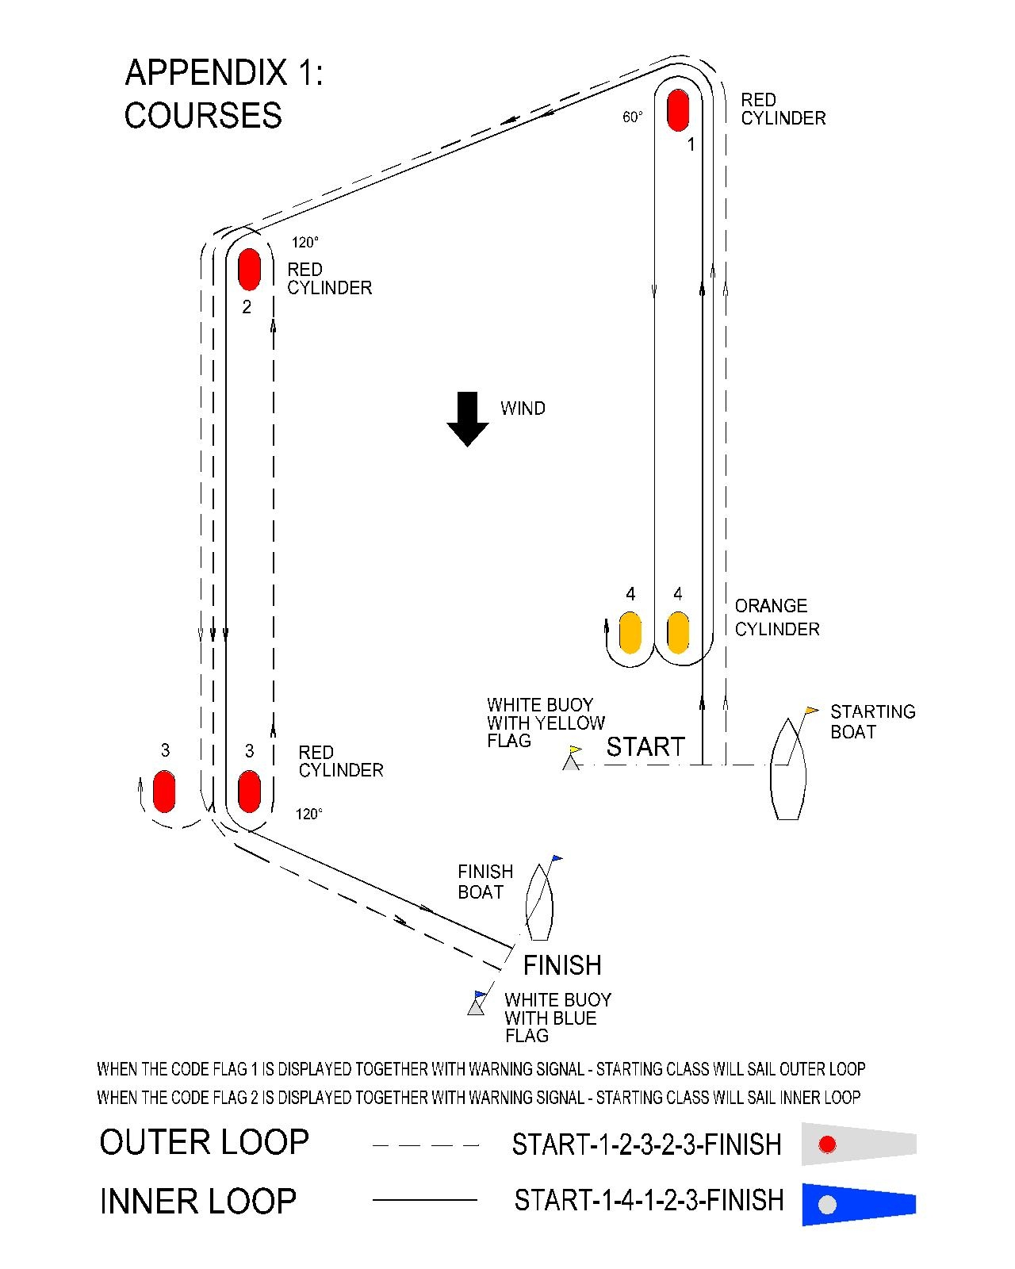
13.4 The boats, which either have not finished the race or have retired the race, have to fill in the appropriate form by the end of the protest time.
13.5 The boats, which broke one of the rule (part two) and accepted the 720º turn penalty, have to record the penalty completion by the end of the protest time.
13.6 A list of boats that, under instruction 1.4 have acknowledged breaking rule 42 or have been disqualified by the protest committee will be posted before the protest time limit.
  - The protest schedule will be posted on the PC notice board within the 15 minutes period after the end of the protest time. Each competitor is required to read all the protest notices within the 30-minutes period after the end of the protest time. Hearings will be held in PC Office.
  - On the last day of the regatta a request for reopening a hearing shall be delivered:
    - ….within the protest time limit if the party requesting reopening was informed of the decision on the previous day;
    - ….no later than 20 minutes after the party requesting reopening was informed of the decision on that day. This changed rule 66.

14. NUMBER OF RACES, VALIDITY OF REGATTA

  - There will be max. 9 races for all classes.

14.2. For validity of this regatta must be at least one valid race.
  - However, all classes have to complete at least 3 races in order to meet the legal requirements of the Czech Cup.

15. SCORING

  - There will be used a ”low points” scoring system which is in accordance with the A Appendix of the RRS.

15.2.1 When fewer than 4 races have been completed, a boat’s series score will be the total of her race scores.
15.2.2 When from 4 to 8 races have been completed, a boat’s series score will be the total of her race scores excluding her worst score.
15.2.3 When 9 races have been completed, a boat’s series score will be the total of her race scores excluding her two worst scores.

16. PRIZES

Prizes will be awarded in accordance with Notice of race (No.9).

17. RADIO – COMMUNICATION, MOTOR BOATS

  - During the race, the crew of the racing boat must not perform any radio communication. Infringements will be sanctioned with disqualification of the boat from regatta or series. This restriction also applies to mobile telephones.
  - Protest committee boats shall display white flag code ”J”. Loss of the “J” flag of the PC boat will not be ground for request for redress.
17.3 All motor boats accompanying particular teams or competitors have to be allowed by the organiser.
17.4. Team leaders, coaches and other support personnel shall stay outside areas where boats are racing from the time of the preparatory signal for first class until all boats have finished or the RC signals a postponement, general recall or abandonment. Racing area is defined in the instruction 8.6 of these SI.
17.5 Breach of the instructions 17.3 and 17.4 may result in disqualification of the boats associated with the accompanying motor boat.
17.6. In case of emergency, to rescue the people and the boats, the instruction 17.5 will not applied.

18. SAFETY REGULATIONS

In Addition to rule 1.2 applies: competitor up to 18 years of age shall wear their personal buoyancy equipment while afloat.

19. LIABILITY

The organisers of this Regatta do not accept any liability for loss, material damage and personal injury caused by, or in connection with this event. All competitors will start at their own expenses, risk and dang.

